6.82: The total work done is the sum of that done by gravity (on the hanging block) and that done by friction (on the block on the table). The work done by gravity is (6.00 kg) gh and the work done by friction is 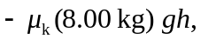 so

This work increases the kinetic energy of both blocks;
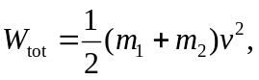
so
